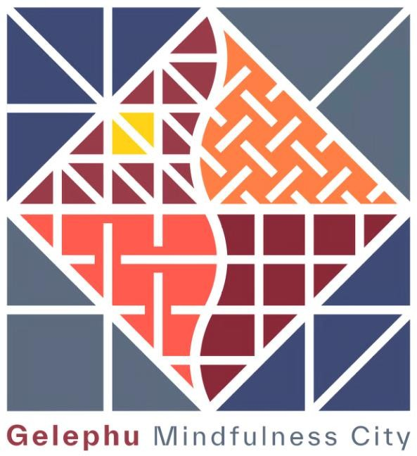

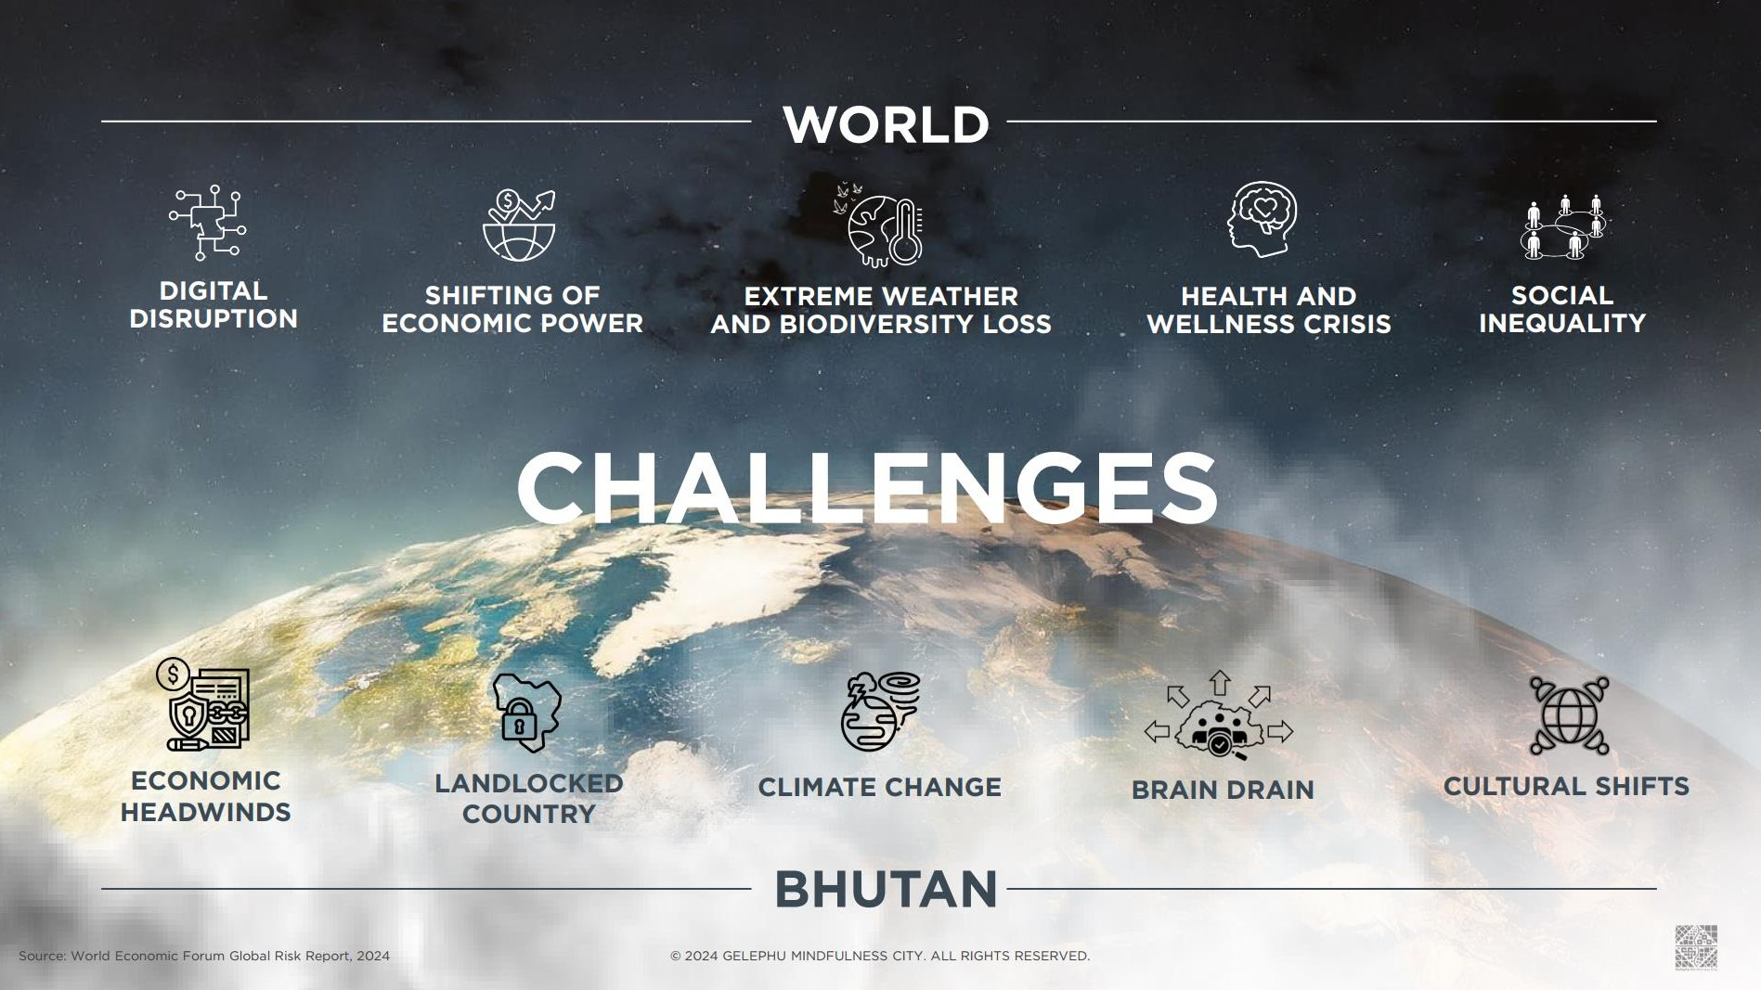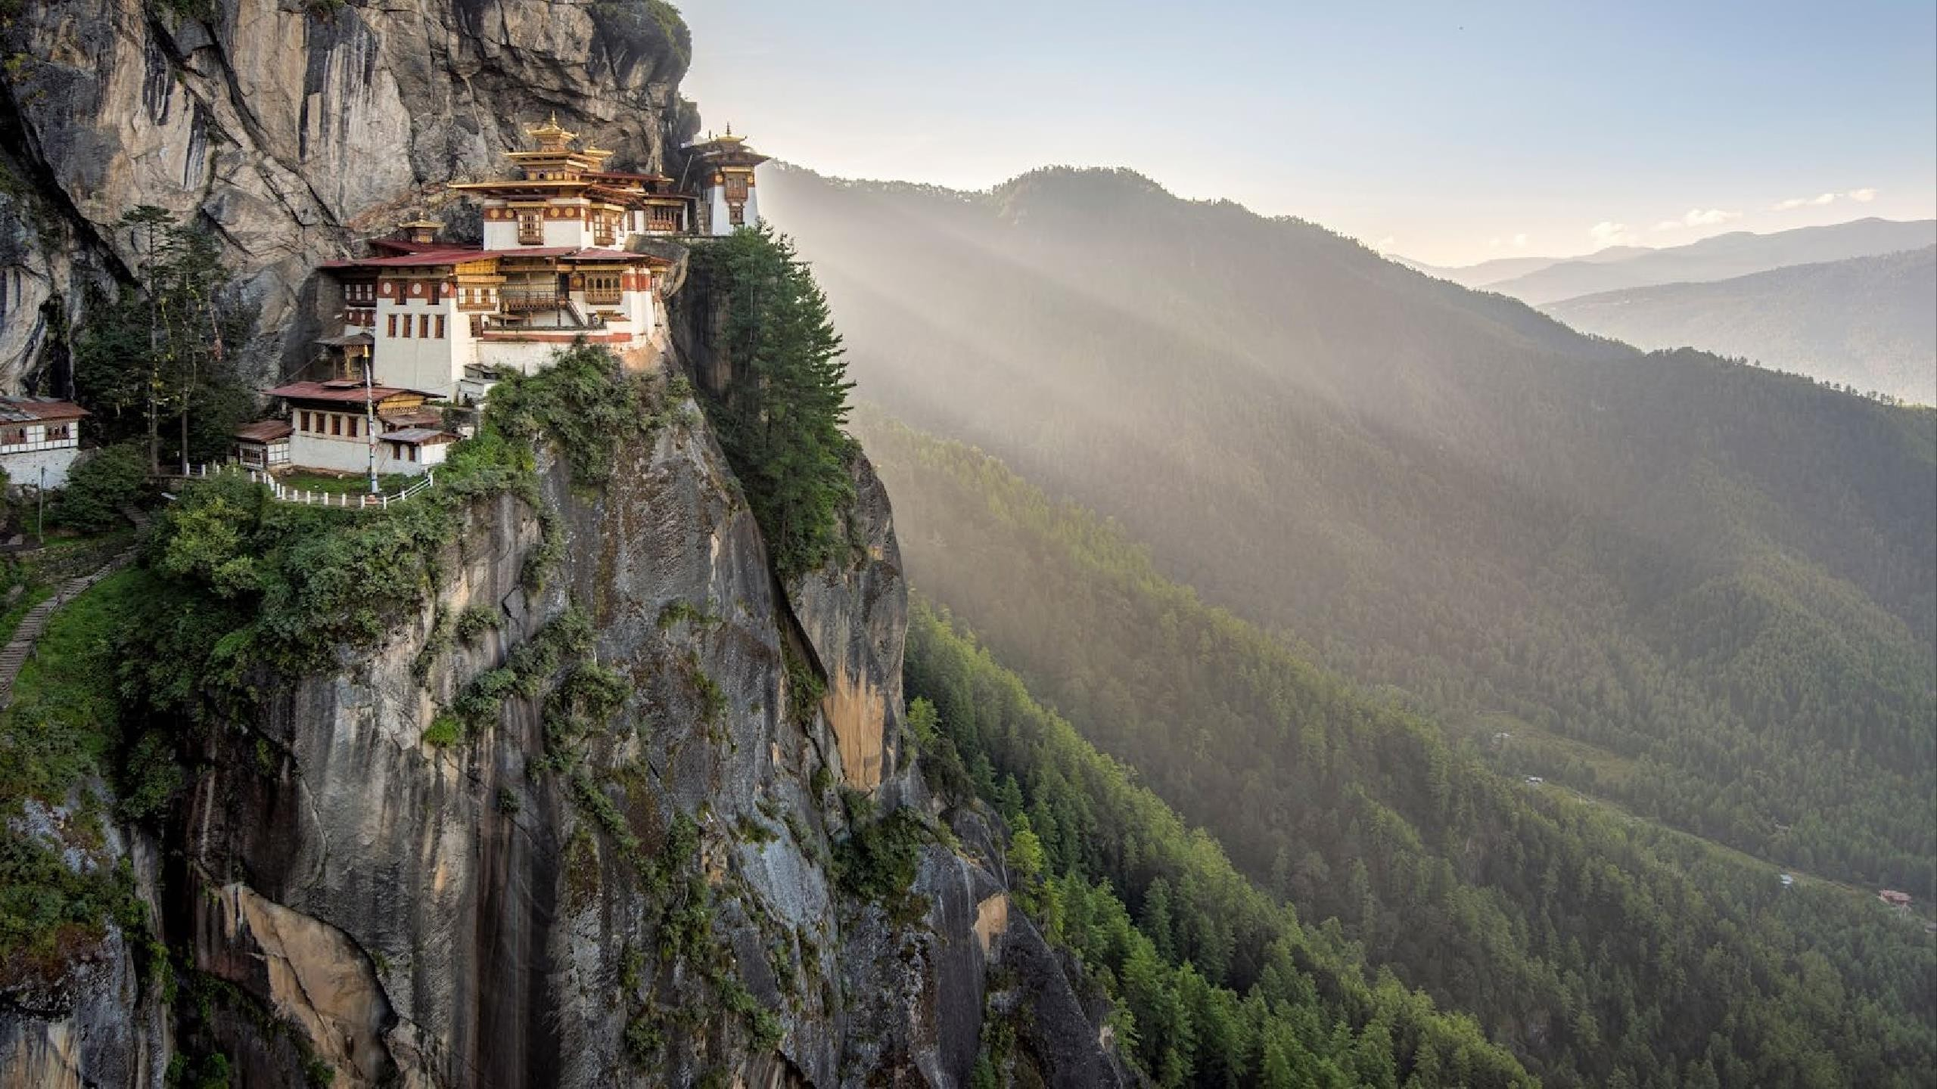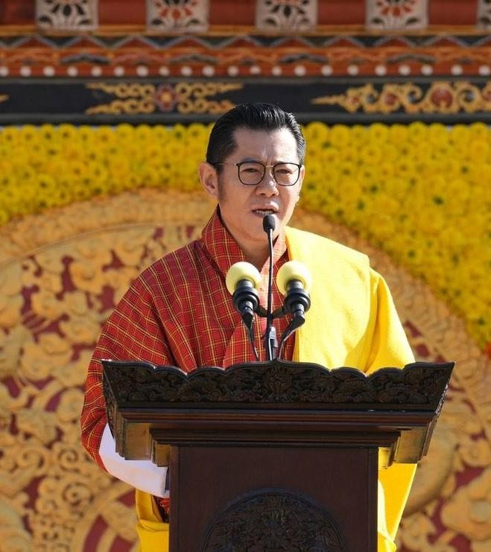

“A period of awakening for South Asia, a period of growth, and a

period of immense opportunities.”

His Majesty King Jigme Namgyel Wangchuck

Bhutan National Day, 17th December 2023

© 2024 GELEPHU MINDFULNESS CITY. ALL RIGHTS RESERVED.

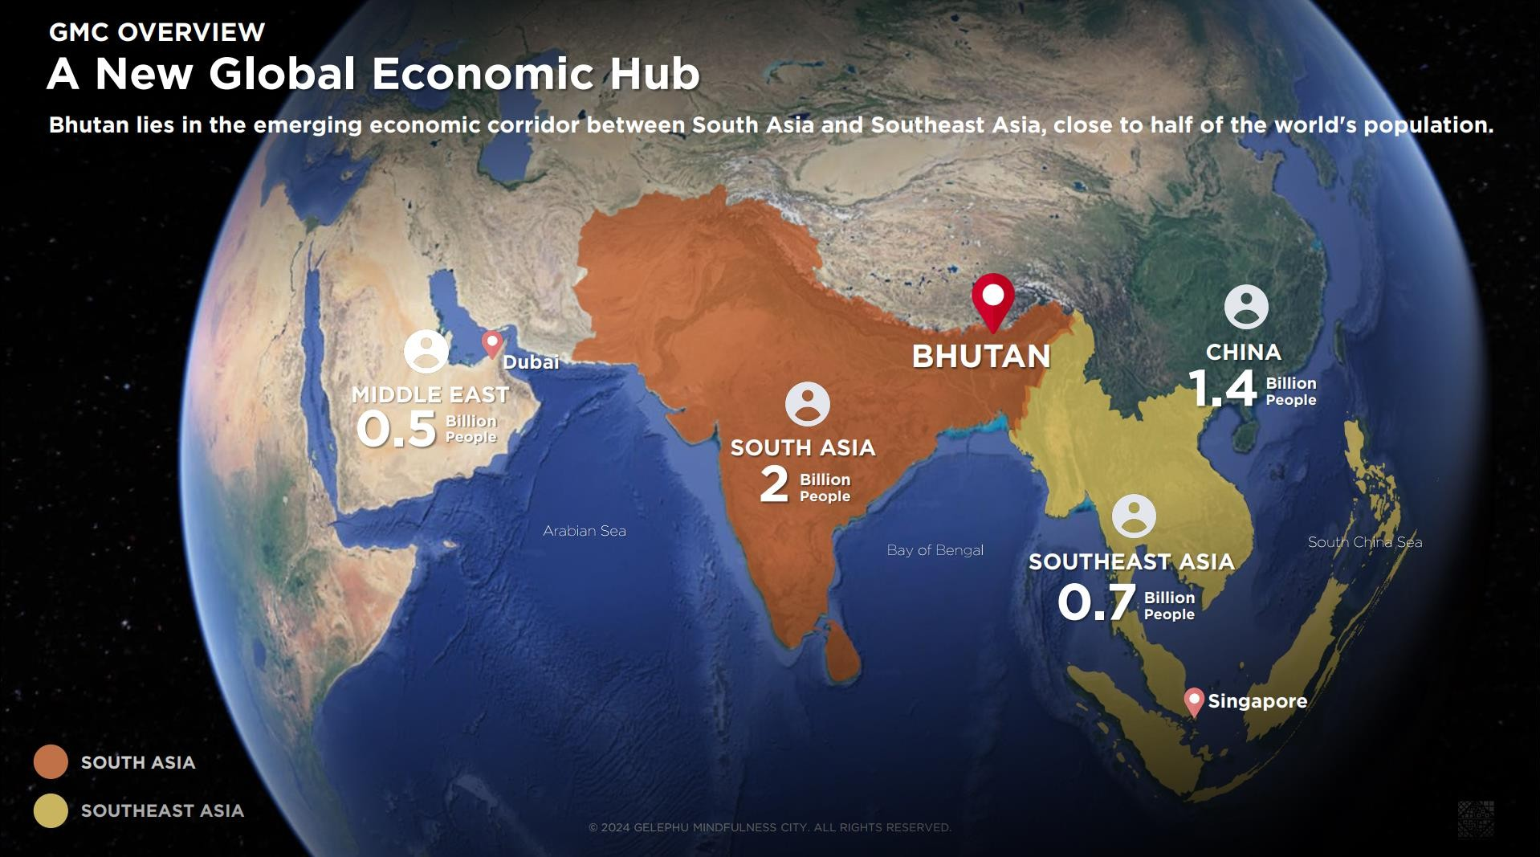

**GMC OVERVIEW**

# Bhutan: The Land of the Thunder Dragon

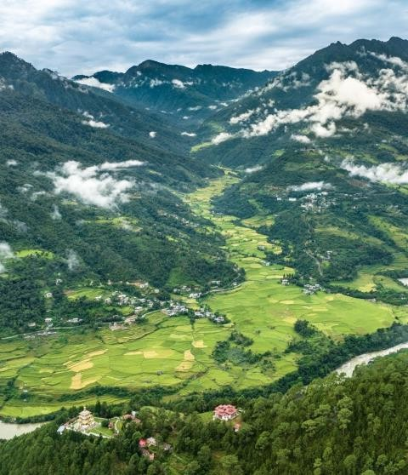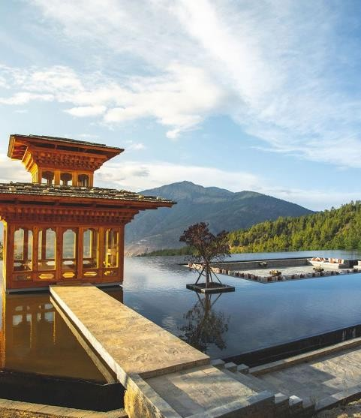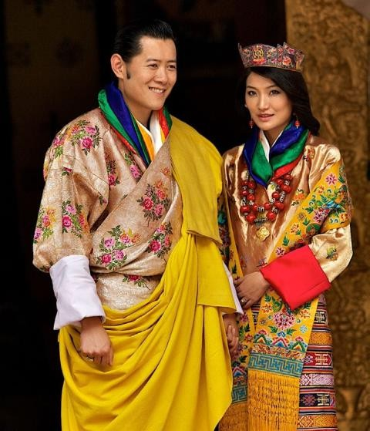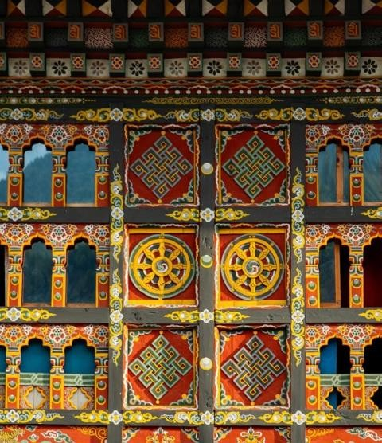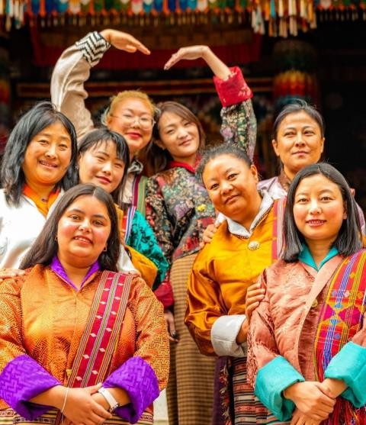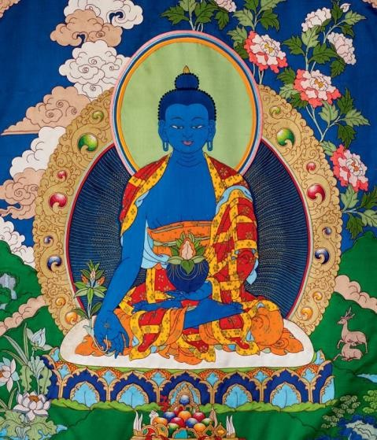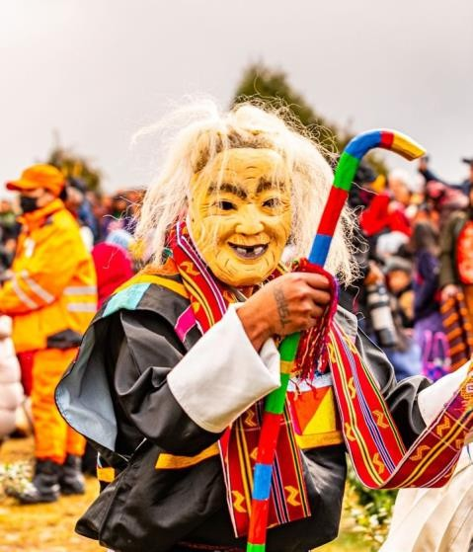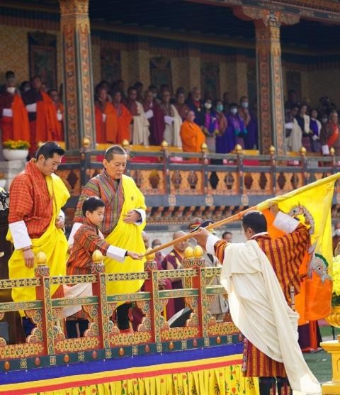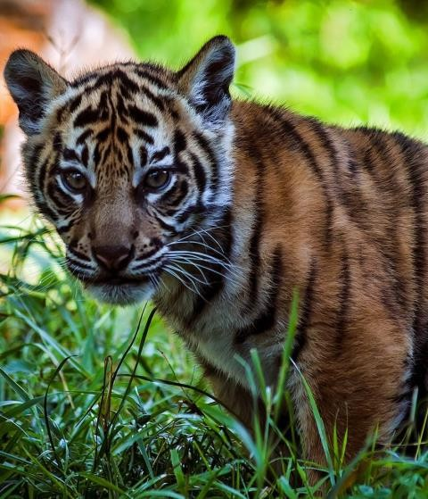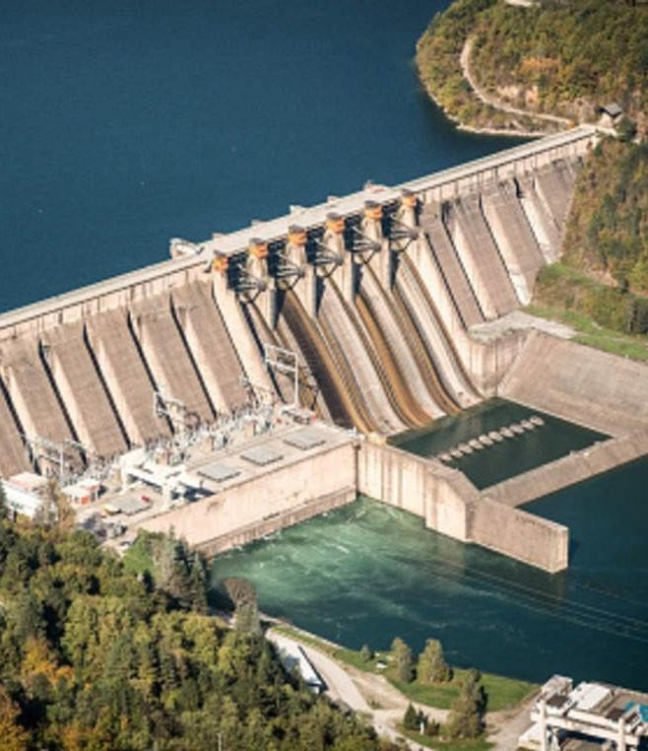

ENLIGHTENED AND STRONG

**LEADERSHIP**

**BUDDHIST SPIRITUAL HERITAGE**

**LUXURIOUS WELLNESS**

**RETREATS**

**UNIQUE CULTURE**

**FORESTS AND BIODIVERSITY**

**TRADITIONAL ARCHITECTURE**

**GNH**

**LANDSCAPE**

**COMMUNITY TRUST**

**INNOVATION AND MODERNITY**

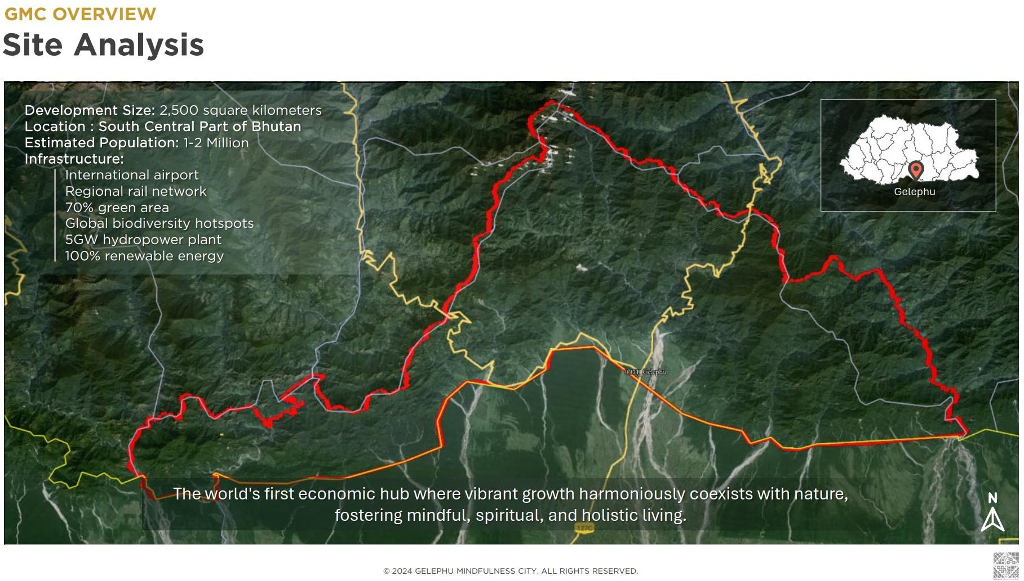

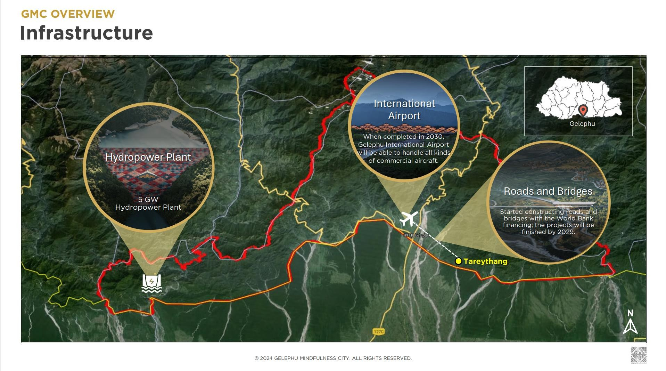

**GMC OVERVIEW**

**Biodiversity**

JIGME SINGYE WANGCHUCK NATIONAL PARK

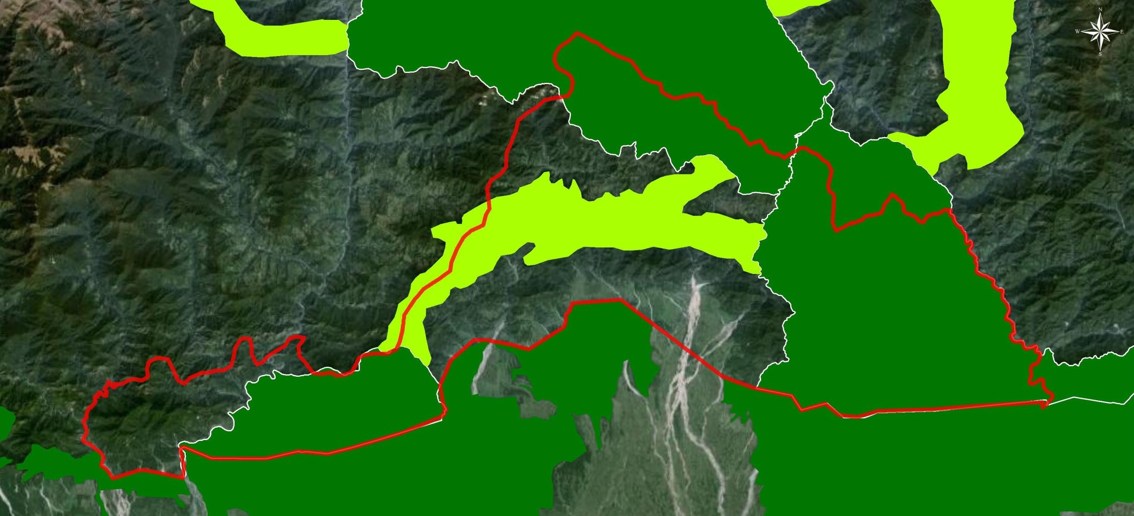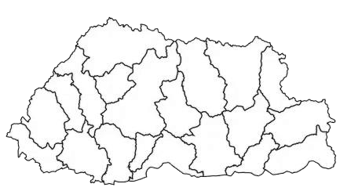

Gelephu

LEGEND

INTERNATIONAL AIRPORT BORDER

GELEPHU TOWN

TAREYTHANG GAYLSUNG CENTRE HYDROPOWER PLANT BIOLOGICAL CORRIDORS

PROTECTED AREAS

Area 2,500 sq.km

## BIOLOGICAL CORRIDORS

INTERNATIONAL AIRPORT

BHUTAN-INDIA BORDER, GELEPHU

ROYAL MANAS NATIONAL PARK

PHIBSOOWILDLIFE SANCTUARY

MANAS NATIONAL PARK

MANAS NATIONAL PARK



**GMC OVERVIEW**

# Key Value Propositions of the Gelephu Mindfulness City



1. STRONG GOVERNANCE

2. ROBUSTINFRASTRUCTURE

3. ADVANCED INDUSTRIES

* SAR with independent governance: Separate executive, legislative, and judiciary systems to foster business-friendly policies like tax and immigration. Early movers can co-create conditions for business success.
* Stewardship of nature & Bhutanese heritage: Development guided by Gross National Happiness (GNH), rooted in Vajrayana Buddhism, unique to Bhutan.
* Robust global connectivity: State-of-the-art airport, roads, rail, and digital infrastructure establish a new economic hub and gateway to South Asia and beyond.
* First carbon-negative country: Circular economy and green energy prioritize minimal environmental impact, fostering nature's flourishing.

Leading industries & future jobs hub: Prime destination for cutting-edge sectors like

Agrifood & Forestry, Wellness & Tourism, Education & Knowledge, Eco-industries & R&D, and Financial & Digital Assets.



**PARTNERS**

# International City Development Expertise

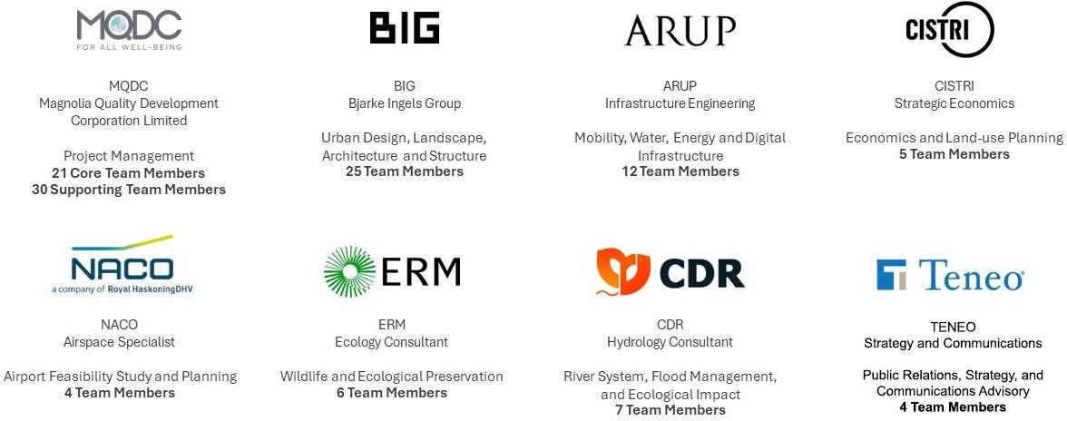

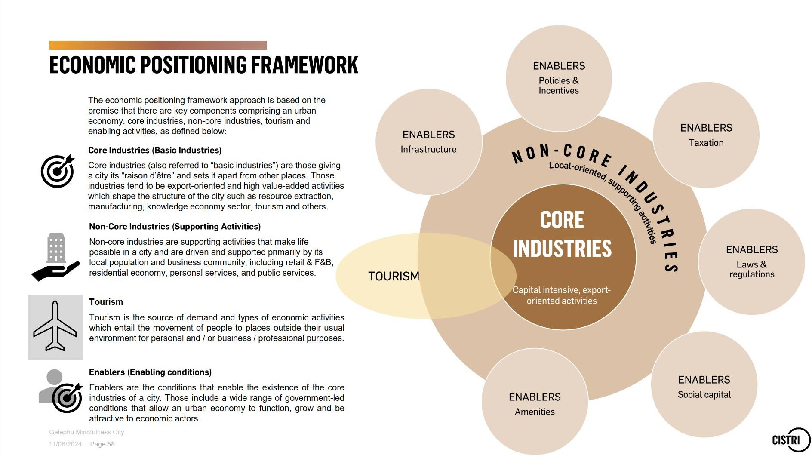

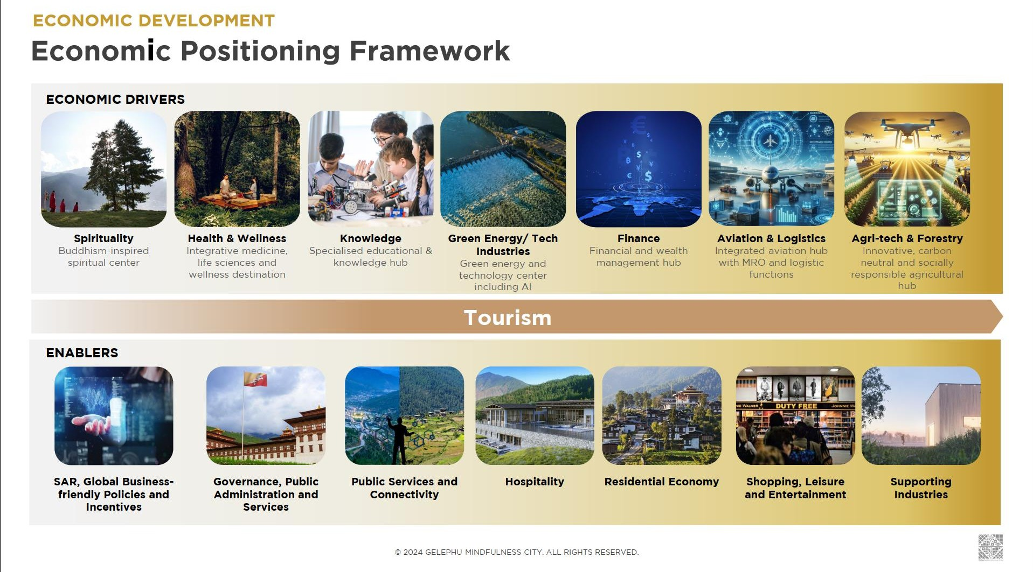

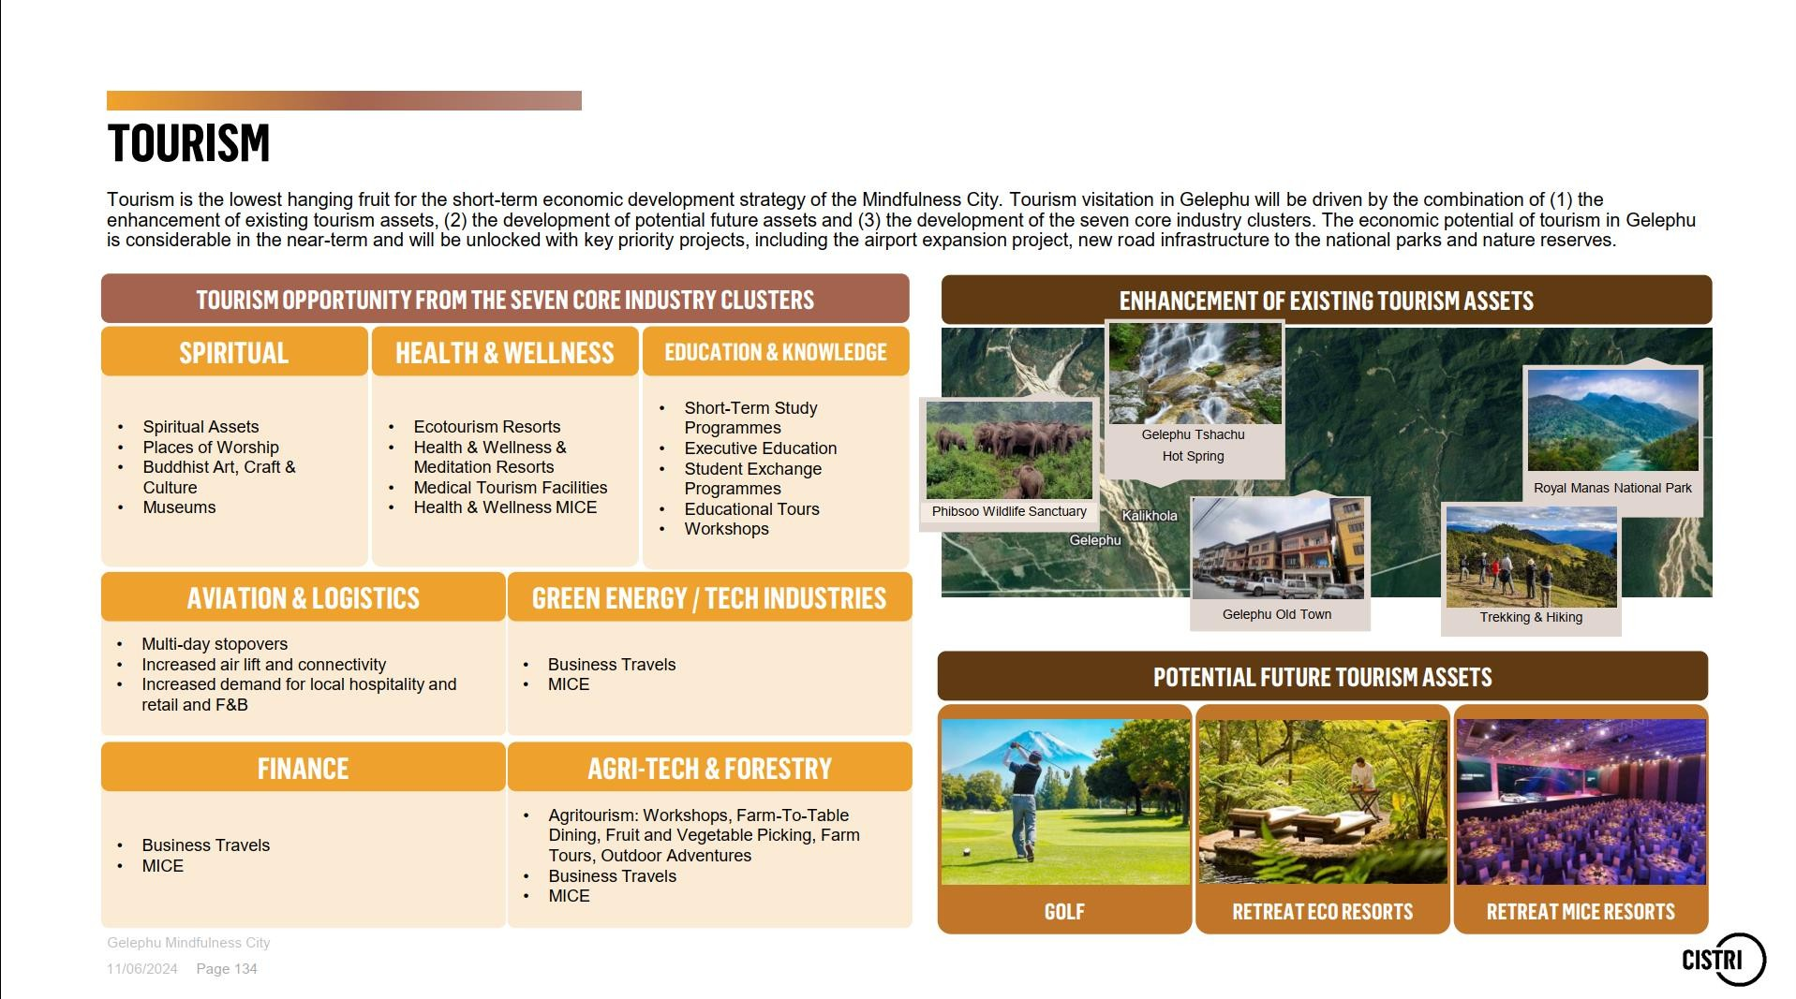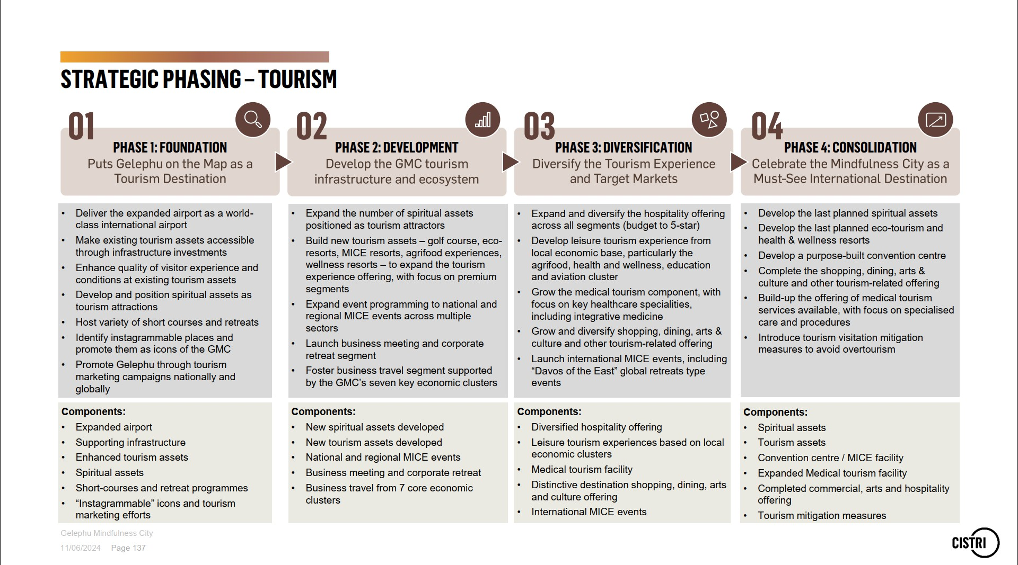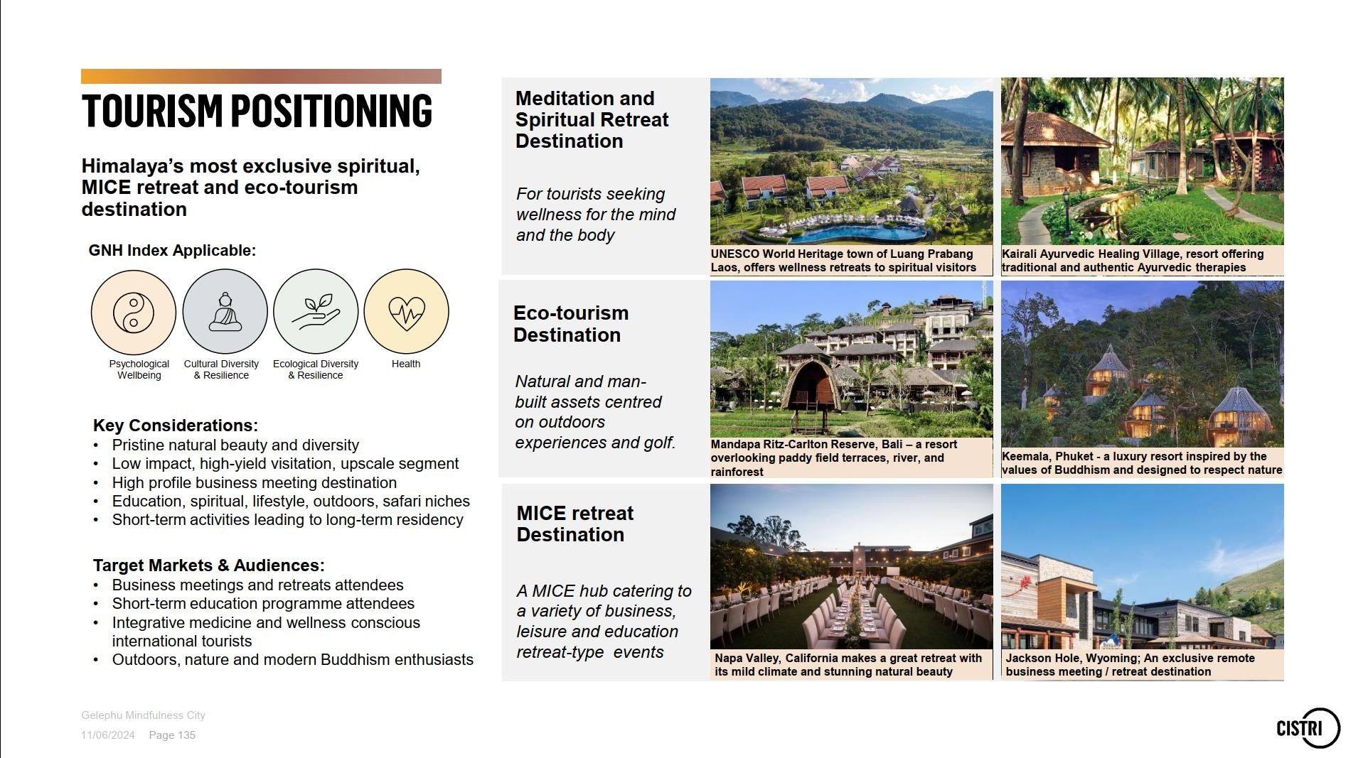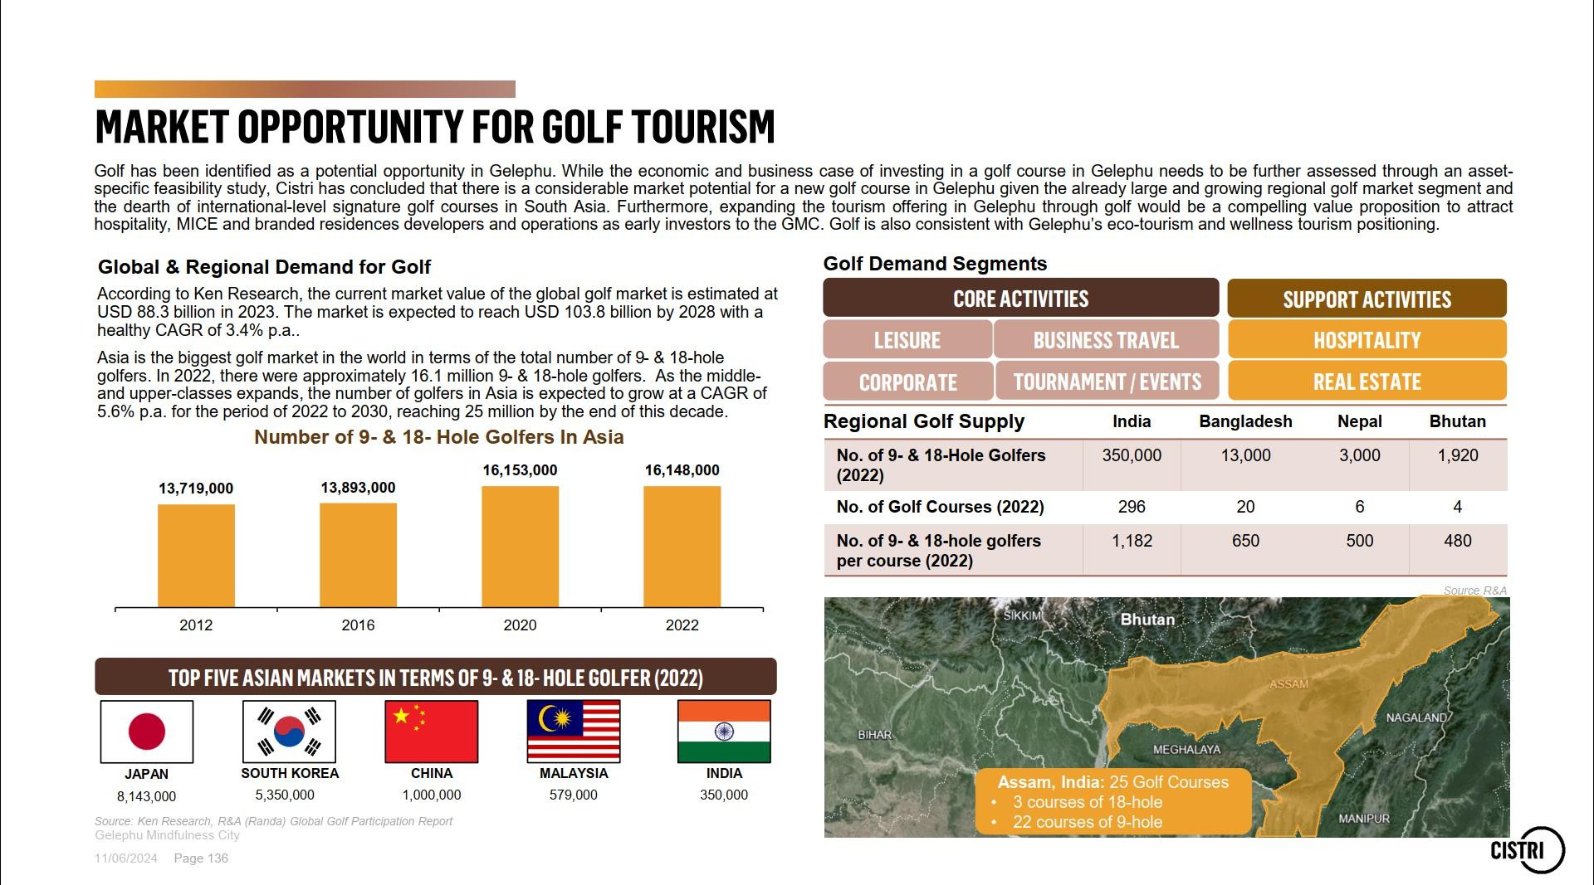

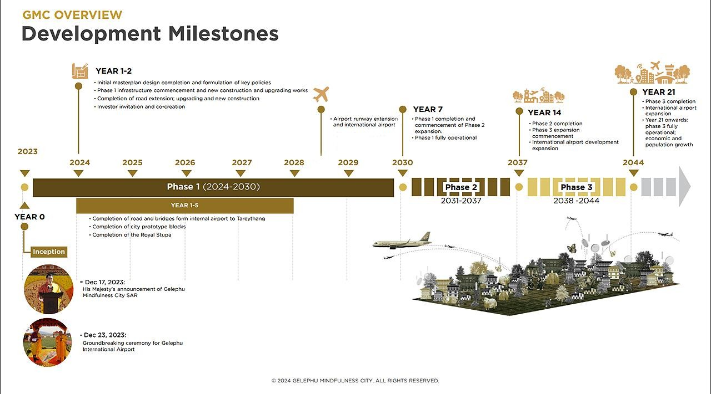

**CURRENT STATUS**

The development of the Gelephu Mindfulness City (GMC) was announced in December 2023.



Extending the runway at Gelephu International Airport. Enhancing the city's infrastructure and road network.

Developing master plans.

Conducting feasibility and site studies.

Evaluating various financing options and initial market sounding.

Redesigning and repurposing existing infrastructure.

Examining potential economic models, policies, and incentives.

**Phase 1**

**Currently**

**Announcement**

**GELEPHU MINDFULNESS CITY**

© 2024 GELEPHU MINDFULNESS CITY. ALL RIGHTS RESERVED.

